|  |  |
| --- | --- |
| **Table of Contents** | **Page #** |
| About the original game Uno | 1-3 |
| About this Version of the Game Uno | 4 |
| How to download the game | 5 |
| How to start a new Uno game | 6 |
| Example of how game is played | 7-16 |

# 

**About the Original Game Uno**

Uno is a card game where people start with the same number of cards. Each player takes a turn to lay down a card that affects the next turn. The first player to run out of cards to play is the winner. The following is a list of rules for the original version of Uno, taken from <https://www.unorules.com/>. Some details have been omitted for simplicity.

# Original Uno Rules

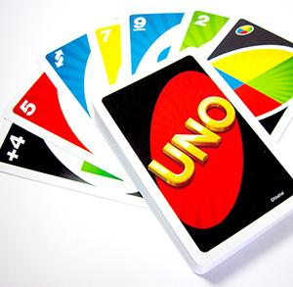**Setup:** The game is for 2-10 players, ages 7 and over. Every player starts with seven cards, and they are dealt face down. The rest of the cards are placed in a Draw Pile face down. Next to the pile a space should be designated for a Discard Pile. The top card should be placed in the Discard Pile, and the game begins!

**Game Play:** The first player is normally the player to the left of the dealer (you can also choose the youngest player) and gameplay usually follows a clockwise direction. Every player views his/her cards and tries to match the card in the Discard Pile.

You have to match either by the number, color, or the symbol/Action. For instance, if the Discard Pile has a red card that is an 8 you have to place either a red card or a card with an 8 on it. You can also play a Wild card (which can alter current color in play).

If the player has no matches or they choose not to play any of their cards even though they might have a match, they must draw a card from the Draw pile. If that card can be played, play it. Otherwise, the game moves on to the next person in turn. You can also play a Wild card, or a Wild Draw Four card on your turn.

**Note:** If the first card turned up from the Draw Pile (to form the Discard Pile) is an Action card, the Action from that card applies and must be carried out by the first player to go (as stated, it is usually the player to the dealer’s left). The exceptions are if a Wild or Wild Draw Four card is turned up.

If it is a Wild card, Mattel has now stated that the first player to start (usually the one on the dealer’s left), can choose whatever color to begin play. If the first card is a Wild Draw Four card – Return it to the Draw Pile, shuffle the deck, and turn over a new card. At any time, if the Draw Pile becomes depleted and no one has yet won the round, take the Discard Pile, shuffle it, and turn it over to regenerate a new Draw Pile.

There are two different ways to play regarding drawing new cards. The Official Uno Rules states that after a card is drawn the player can discard it if it is a match, or if not, play passes on to the next player. The other type is where players continue to draw cards until they have a match, even if it is 10 times.

The game continues until a player has one card left. The moment a player has just one card they must yell “**UNO**!”. If they are caught not saying “Uno” by another player before the next player has taken their turn, that player must draw two new cards as a penalty. Assuming that the player is unable to play/discard their last card and needs to draw, but after drawing, is then able to play/discard that penultimate card, the player has to repeat the action of calling out “Uno”. The bottom line is – Announcing “Uno” needs to be repeated every time you are left with one card.

Once a player has no cards remaining, the game round is over, points are scored, and the game begins over again. Normally, everyone tries to be the first one to achieve 500 points, but you can also choose whatever points number to win the game, as long as everyone agrees to it.

**Action Cards:** Besides the number cards, there are several other cards that help mix up the game. These are called Action or Symbol cards.

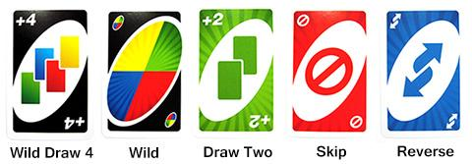

* **Reverse** – If going clockwise, switch to counterclockwise or vice versa. It can only be played on a card that matches by color, or on another Reverse card. If turned up at the beginning of play, the dealer goes first, and the player to the dealer’s right is next (normally it would be the player to the dealer’s left).
* **Skip** – When a player places this card, the next player has to skip their turn. It can only be played on a card that matches by color, or on another Skip card. If turned up at the beginning of play, the first player (to the dealer’s left) loses his/her turn. The next player to that player’s right starts the game instead.
* **Draw Two** – When a person places this card, the next player will have to pick up two cards and forfeit his/her turn. It can only be played on a card that matches by color, or on another Draw Two. If turned up at the beginning of play, the first player draws two cards and gets skipped.
* **Wild** – This card represents all four colors, and can be placed on any card. The player has to state which color it will represent for the next player. It can be played regardless of whether another card is available. If turned up at the beginning of play, the first player chooses what color to continue play.
* **Wild Draw Four** – This acts just like the wild card except that the next player also has to draw four cards as well as forfeit his/her turn. With this card, you must have no other alternative cards to play that matches the color of the card previously played. If you play this card illegally, you may be challenged by the other player to show your hand to him/her. If guilty, you need to draw 4 cards. If not, the challenger needs to draw 6 cards instead. If turned up at the beginning of play, return this card to the Draw pile, shuffle, and turn up a new one.

**About this Version of the Game Uno**

Our version of Uno is mostly based off of the original game and includes most of the same rules. However, some aspects may be different, such as the rule about calling uno (see below). Also, there are many different versions of the game Uno. Below are some rules that our game follows, which may be different from the original or other versions.

**Calling Uno**

You must call Uno before playing your second-to-last card. Failing to do so will result in a card penalty. Press the Uno! button to call Uno.

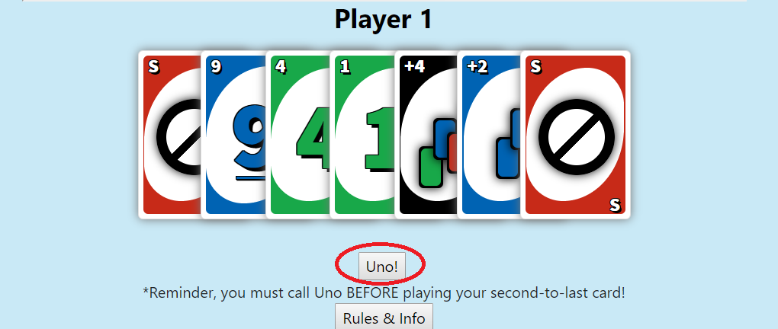

**Drawing Until a Valid Card is Found**

If you do not have a valid card, you must draw until you get one to play.

**Special Rules**

There are no special rules in this version (e.g swap decks)

**Draw 2’s stack, Draw 4’s stack**

If a Draw 2 card is played, the next player can prevent having to draw 2 cards by playing their own Draw 2 card. Every player can repeat this strategy if they have the card. If a player does not have a draw 2 card, they must draw two cards for every Draw 2 card that was played. For example, if three Draw 2 cards were played, the player without their own Draw 2 card must now draw 6 cards. This same rule applies to Draw 4 cards. However, a Draw 2 card does not stack with a Draw 4 card or vice versa.

**How to download the game**

**System Requirements**

You will need Internet access in order to download the game. Once you have downloaded the game, you will not need Internet access in order to play it. This game can be played on multiple browsers such as Chrome, Firefox, and Internet Explorer.

**How to Download**

1. Go to your Desktop, right-click and select the option to open the Command Prompt or Terminal
2. Type “git clone <https://github.com/Earving8/uno.git>” and press Enter
3. Now the game is in the new folder on your Desktop. Open the folder
4. Open the index.html file. The game should open in your browser.

**How to start a new Uno game**

1. Open the index.html file (see How to Download the Game section for help)
2. There is a form where you can fill out two things, “Player Name” and “How many Players”. Under “Player Name”, type any name you want to represent yourself in the game. If you do not want to play the game and want to watch a game with only Bots, then type “Bot” under “Player Name” instead.
3. Under “How many Players”, select an option from the drop-down menu. A game can have a minimum of two players and a maximum of four players.

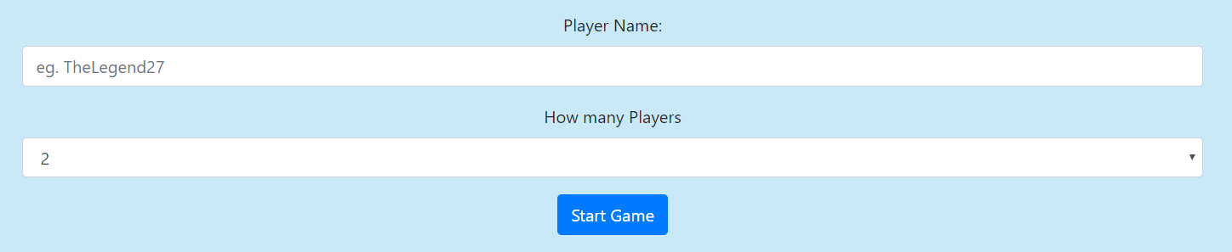

**Example of how game is played**

To learn the rules of how the game is played, please review the “About the Original Game Uno” section beginning on page 1. It is also important to review the “About this Version of the Game Uno” section on page 4. Below is an example of what it looks like to play the game.

**Example Game**

|  |  |
| --- | --- |
|  | Player 1 begins. The first playfield card is always random, and in this case it is a Green 5. Player 1 must play either a matching color, number, or valid special card. Here, Player 1 can choose the Green 4, Green 1, or special +4. Player 1 decides to choose Green 4. To do this, Player 1 drags the mouse over the card and left-clicks it to play it. |
|  | Player 1 played the Green 4 card, so it appeared on the playfield next to the original Green 5 card and is no longer in Player 1’s hand. The next player, Aman Justasyu, chose to play a Green 7, and it appeared next to the Green 4 card played by Player 1. Now Player 1 must play another valid card. They can play either a Green 1 or a special +4 card. Player 1 decides to play the special +4. |
|  | Notice the special +4 card is in the discard pile along with the previously played cards. To complete their turn, Player 1 must choose a new color (Red, Yellow, Blue, or Green). To do this, they select the option they want from the newly-appeared list of options and click the “Pick” button as shown in this image. If you do not see this on your screen, scroll down the page and look in the bottom-left area. |
|  | Here is a close-up of the previous image, showing the prompt to choose a new color. Player 1 clicks the radio button next to the color they want, and clicks the “Pick” button. Player 1 decides to choose color Red and clicks “Pick”. |
|  | Player 1 chose Red as the new color, so the special +4 card that was in the discard pile now appears as a blank red card to symbolize the color change. The next player, Aman Justasyu, was forced to Draw 4 cards. Now it is Player 1’s turn. Player 1 must play either one of their Red Skip cards. Player 1 chooses one of them. |
|  | Player 1’s Red Skip card appears in the discard pile next to the blank red card. Notice there are five cards shown in the discard pile now, the first being the original random card and the fifth being the card Player 1 just played. Only 5 cards will be shown in the discard pile. When the next card is put in the discard pile, the oldest card (Green 5 in this case) will no longer be shown in the pile.  Aman Justasyu loses his turn due to the Red Skip card. Player 1 can only play their remaining Red Skip card, so they choose that one. |
|  | Player 1 played their Red Skip card, and Aman Justasyu lost their turn again. It is Player 1’s turn again. Uh-oh, Player 1 doesn’t have any valid cards to play. Player 1 must draw from the deck of cards on the playfield located above the discard pile, shown in this image. To get a new card from this deck, Player 1 mouses over the deck and left-clicks it. |
|  | Luckily, Player 1 drew a valid card on their first try. Player 1 plays their only valid card, a Red 7. |
|  | Aman Justasyu played a Red 3. Player 1 does not have any valid cards and must once again draw from the playfield deck. |
|  | Player 1 drew from the deck and received a Blue 2 card. Player 1 still does not have a valid card to play and must continue to draw from the deck until they receive a valid card. |
|  | Player 1 drew a special Wild card on their second try. They play this card which is the only valid option for them to play. |
|  | Player 1 chose the Wild card and a list of color options has appeared in the lower-left corner, just like when Player 1 chose a special +4 card earlier in the game. Player 1 chooses Blue as the new color and clicks the “Pick” button. |
|  | Player 1 chose Blue and the Wild card in the discard pile has become a blank Blue card to reflect the change in color. Aman Justasyu played a Blue 8 card and it is Player 1’s turn again. Player 1 can choose a Blue 9, Blue +2 card, or Blue 2. Player 1 chooses the Blue +2 card. |
|  | Player 1 played the Blue +2 card and Aman Justasyu had to draw 2 cards. If Aman Justasyu had chosen to play another +2 card of any color, Player 1 would have to either play another +2 card if they had one, or draw 4 cards from the deck since two +2 cards were played. In this case, Aman drew 2 cards and it is Player 1’s turn again. Player 1 can play a Blue 9 or a Blue 2. Player 1 chooses to play a Blue 9. |
|  | Player 1 chose a Blue 9. Aman Justasyu played a special +4 card and changed the color to yellow, represented by the blank yellow card in the discard pile. Notice the playfield deck has a “+4” written on top of it now. This means Player 1 must either play another special +4 card or click on the playfield deck and draw 4 cards. Player 1 only has one choice in this case and clicks on the playfield deck to draw 4 cards. |
|  | Player 1 drew 4 cards from the deck. Aman Justasyu played a Yellow 3 card. Player 1 does not have any yellow cards, but does have a Blue 3 card. Since this card matches the number, it can be played even though it is not a yellow card. Player 1 chooses to play the Blue 3 card. |
|  | Player 1 played the Blue 3 card. Now the color is Blue instead of Yellow. Aman Justasyu played a Blue 1 card. It is Player 1’s turn again. Player 1 can play a Green 1 or a Blue 2. To speed up this example game, the players will play through a few rounds without displaying what happens in these images. The next image will be an update of the game after several turns have been played. |
|  | A few rounds have passed. Player 1 has just played a Red Draw 2 card, and Aman Justasyu was forced to draw 2 cards. It is Player 1’s turn again. Notice Player 1 only has two cards left. Player 1 must remember to click the “Uno!” button at the bottom of the screen before playing their next card. If they do this, they will successfully be down to 1 card. If they forget to click the “Uno!” button before playing their second-to-last card, then they will receive a penalty and be forced to draw 2 cards after playing their second-to-last card. Player 1 remembers this rule and clicks “Uno!”, and then plays the Red 6 card. |
|  | Player 1 played the Red 6 card. Aman Justasyu played a Green 6 card. It is Player 1’s turn, and luckily their last card is also a Green card. Player 1 chooses to play their Green 1 card. |
|  | Player 1 clicked their Green 1 card. Since it was their last card, a pop-up message appears announcing the winner. It says “Player 1 wins!” and now the game is over. Congrats, Player 1! |